Java Homework 3

Problem 1:

Please see the textbook p173~p174 for the details.

You can extend these problems into more advanced.

For example: The use can provide the number of the lines

fan out from four corners, ….colored lines.

(1).

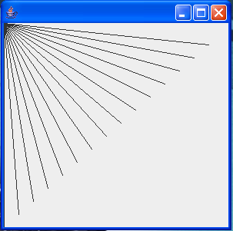 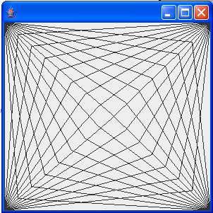 p fig4.20(a) fig4.20(b)

(a).Create the design in the left screen capture of fig4.20(a).

The design draws lines from the top-left corner, fanning out the lines until they cover the upper-left half of the panel.

(b). Modify your program in part (a) to have lines fan out from all four corners, as shown in fig4.20(b). Lines from opposite corners should intersect along the middle.

(2).

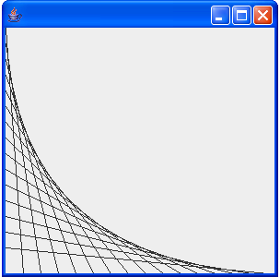 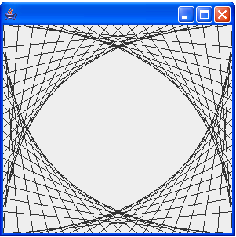

Fig4.21 (a) fig4.21 (b)

(a).Create the design in the left screen capture of fig4.21 (a).

Begin by dividing each edge into an equal number of increments. The first line starts in the top-left corner and ends one step right on the bottom edge. For each successive line, move down one increment on the left edge and right one increment on the bottom edge. The figure should scale as you resize the window so that the endpoints always touch the edges.

(b).Modify your program in part (a) to mirror the design in all four corners, as shown in fig4.21 (b).

Problem 2: Finding the closet pair

Given a set of point, the closet-pair problem is to find the two points that are nearest to each other. An intuitive approach is to compute the distances between all pairs of points and find the one with the minimum distances.

Example: (-1, 3), (-1, -1), (1, 1), (2, 0.5), (2, -1), (3, 3), (4, 2), (4, -0.5)

The points (1, 1) and (2, 0.5) are closet to each other.

Hint: There are several ways to solve this problem. An intuitive approach is to compute the distances between all pairs of points and find the one with the minimum distance.

Problem 3: Using BigInteger and BigDecimal classes

1. The BigInteger and BigDecimal classes can be used to represent integers or decimal numbers of any size and precision.
2. The BigInteger and BigDecimal classes are in java.math package.
3. You can use new BigInteger(String) and new BigDecimal(String) to create an object of BigInteger and BigDecimal.
4. Use add, subtract,…methods to perform arithmetic operation

Case I. Please write one java application program to show the arithmetic operations of big data (at least 30 digits)

Case II. Please write a java application program to calculate the factorial of an integer n, the value of n is at least 45.